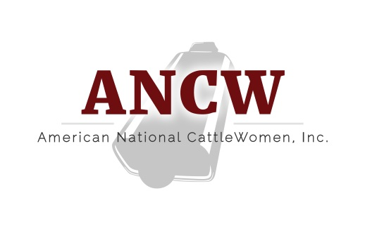
American National CattleWomen, Inc.
200 NW 66th Street, Suite 972
Oklahoma City, OK 73116
(303) 850-3441
ancw@ancw.org
For Office use
Date Rec’d : _______
Ck #: ___________
Amt: ___________

Today’s Date: _____________________

Please return this page with your dues payment to the address above.
Your cancelled check will be your receipt. All paid memberships
receive the quarterly newsletter by email. Please print clearly.
*Name:
Organization/Business:
*Address:
*State *Zip code:
*E-mail address:
Your email address is used exclusively for CattleWomen activities and business correspondence.
*Telephone: Home: Mobile:
*Birth date (Needed for Junior, Collegiate, or Golden Cowgirl verification): / /
*My membership is: PLEASE mark appropriate category. New |  | Renewal
*Encouraged to Renew/Join by (name of ANCW member):
*State Affiliate association (state I wish my national membership listed under)
Please send me a new membership card (mark the box if you would like a card)
*Required Field
Membership Options - Please check the appropriate level  Due October 1 annually. | Membership  October 1 to September 30.
Junior – Age 0 to 18 years |    $ 20.00
Collegiate -- College student, age 19 to 24 years |    $ 20.00 
Basic – Adult membership |    $ 60.00 
Sustaining – Basic membership “plus donation” |    $ 85.00 
Associate – Business or organization membership (non-voting) |    $ 150.00
Affiliate – State units bearing the name CattleWomen or Cowbelles, breed organizations or other industry related groups |    $ 250.00
**Lifetime - A one-time payment |    $1,000.00
Subscription Fee The American CattleWoman Quarterly ANCW Newsletter (Annual fee) |    $ 10.00
ANCW Newsletter Options:
I am an ANCW member over the age of 65 years, As a Golden Cowgirl, I would like
to receive a copy of the printed newsletter at no charge.
**Receives the printed newsletter automatically.

