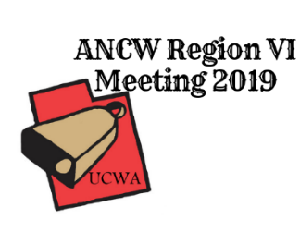
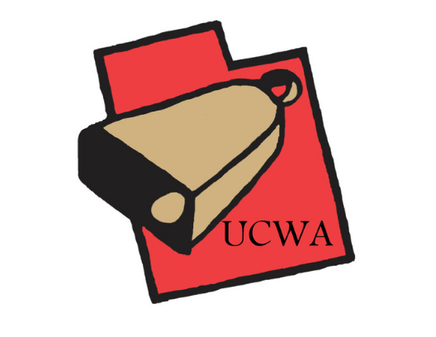

Sponsorship Form
Utah Cattlewomen’s Association
Yes, I would like to collaborate with the Utah Cattlewomen’s Association in hosting the ANCW Region VI meeting, which will take place May 6-8, 2019 in Bear Lake, Utah. Please contact Nikki Weston, 208-847-5243, with any questions.
Sponsorships are available in the following levels:
- Silver Level- up to $99
-UCWA website and social media presence
- Company logo on programs

- Gold Level- $100-$999
-UCWA website and social media presence
- Company logo on programs
-Meal Sponsorship advertising

- Diamond Level- $1,000-$1,999
-UCWA website and social media presence
- Company logo on programs
-Meal Sponsorship advertising
-Company Logo on banner, which will also be displayed at Summer and Winter Conventions

- Platinum Level- $2000 and above
-UCWA website and social media presence
- Company logo on programs
-Meal Sponsorship advertising
-Company Logo on banner, which will also be displayed at Summer and Winter Conventions
-Company Logo on attendee goody bag

We appreciate sponsors, as they will assist in offsetting the cost the Region VI meeting. As a sponsors, you will be recognized at the meeting and have your logo printed in the spring newsletter. Other opportunities are available for Diamond and Platinum level sponsorships. Thank you for your consideration of this request. We are a 501(c)3 organization.
Date: _________________
Sponsorship Amount: ______________ to the Utah Cattlewomen’s Association
Sponsor Name: _________________________________
Address: ______________________________________
City, State, Zip: _________________________________
Phone: _______________________________________
Email: ________________________________________
Please make check payable to UCWA
Send Donation to:
UCWA
150 South 600 East
Suite 10-B
SLC, UT 84102

